Cronometro

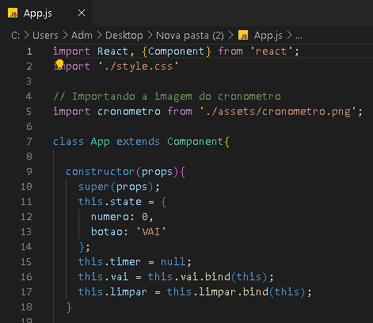

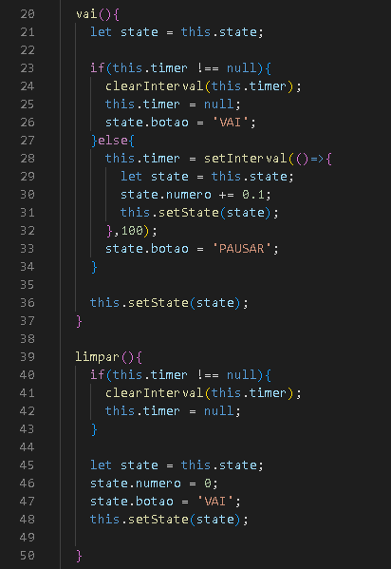

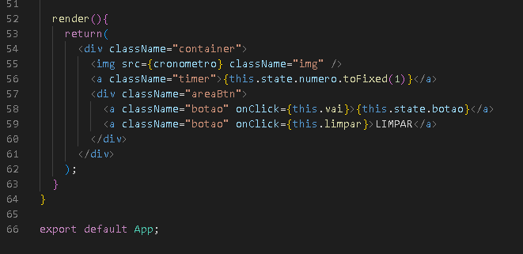

Arquivo style.css:

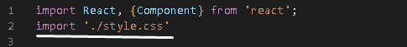

.container{
display: flex;
width: 100%;
align-items: center;
justify-content: center;
flex-direction: column;
}

.img{
width: 350px;
height: 350px;
padding-top: 100px;
}

.timer{
font-size: 130px;
margin-top:-250px;
}

.areaBtn{
margin-top:100px;
display: flex;
}

.botao{
width: 150px;
background-color: #FFF;
font-size: 20px;
text-align: center;
border-radius: 5px;
margin-left: 15px;
margin-right: 15px;
cursor: pointer;
padding: 5px;
}

.botao:hover{
opacity: 0.7;
color: #000;
transition: all 0.50s;
}

